CURRICULUM VITAE
of
Nourhan Hussien

Faculty of Medicine

Benha University

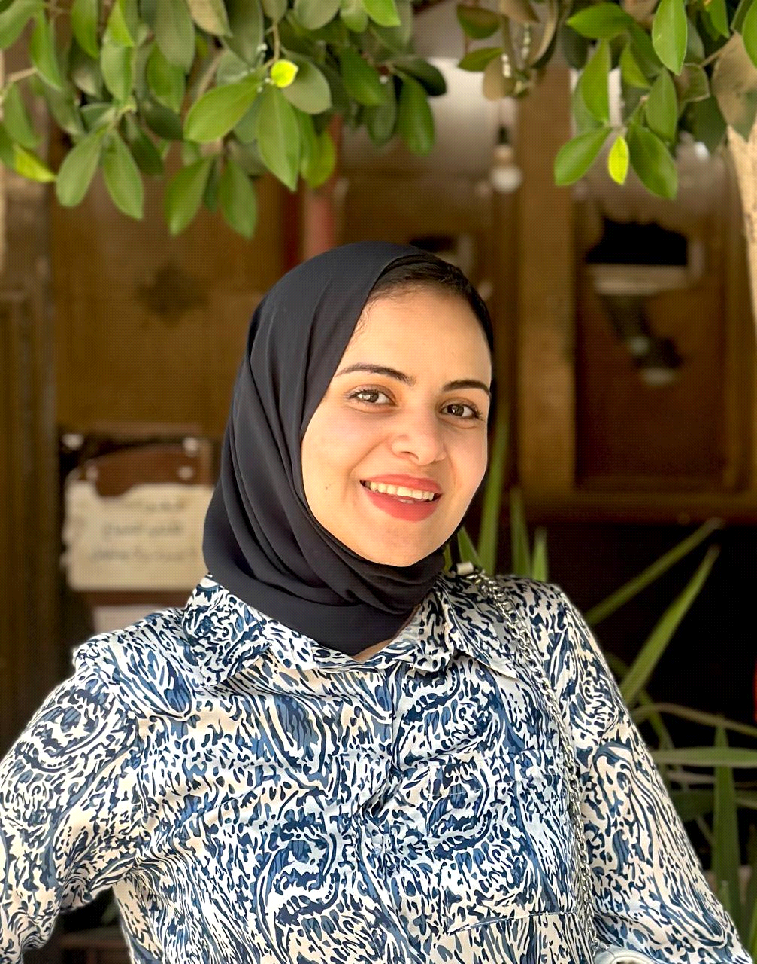

Personal photo

- Personal Data
Name (Arabic) | نورهان حسين مغاوري السعدني
Name (English) | Nourhan hussein moghawry elsaadany
Department | Forensic Medicine and clinical Toxicology
College | Benha Faculty Of Medicine
Academic degree | Demonstrator
Mobile | 01025253466
Home phone | 0133208026
work phone | -
Email (university)
Alternative E mail | nourhanhussein570@yahoo.com
Web site | -

- Education
Institution | Degrees obtained | Year
Benha University | Bachelor's degree of medicine and surgery | 2022
Benha University
Benha University

General specialty | Medicine and general surgery
Specific specialty | Forensic medicine and clinical toxicology
- Language
Language | Reading | Speaking | Writing
Arabic | good | good | good
English | good | good | good

- Membership of Professional Bodies (List)

- Interesting Areas of Research

- MSc Supervision
Title | Year completed / in  Progress

- PhD Supervision
Title | Year completed / in progress

- Positions
Date From - to |  | Organization | Country | Position | Role
1 | 2024 till present | Benha faculty of medicine | Egypt | Demonstrator | Teaching
2
3
4
5

- Attended Workshops, Symposiums, and Conference
Name of Workshops, Symposiums, and Conferences | Year

- Training and Clinical Experience:
a-
b-

- Skills:

b.

- List of publications:

